VPC CHALLENGES

Use Case: Setting up Transit Gateway and VPC Endpoints for a Multi-VPC Architecture
Scenario:
A large organization is migrating its on-premises infrastructure to the AWS cloud.
The organization's architecture involves multiple VPCs for different departments and applications, each requiring secure communication with centralized services and external resources.
The IT team needs to design and implement a scalable and efficient network architecture to accommodate the organization's growth and ensure robust connectivity between VPCs and external services.
Objectives:
- Design and deploy a scalable network architecture using AWS Transit Gateway to simplify network connectivity between multiple VPCs.
- Configure VPC endpoints to securely access AWS services without internet gateways or NAT gateways, ensuring data privacy and minimizing exposure to external threats.

Set up a VPC Transit Gateway.

Go to aws console
Go to VPC service
Create multiple VPC
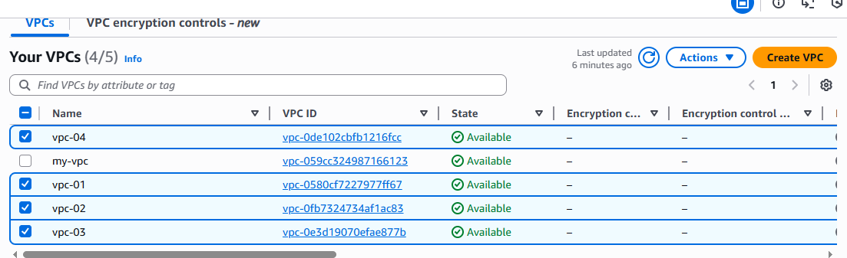
Go to internet gateway and create multiples internet gateway and attach to VPC
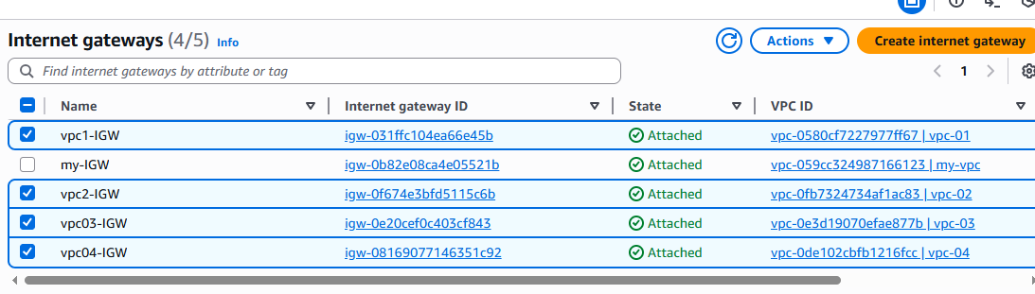
create multiple subnet for multiple VPC
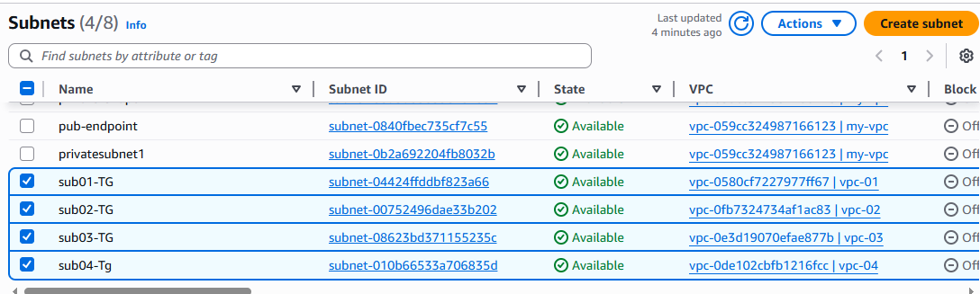

create multiple route tables for multiple subnets and associate with subnets
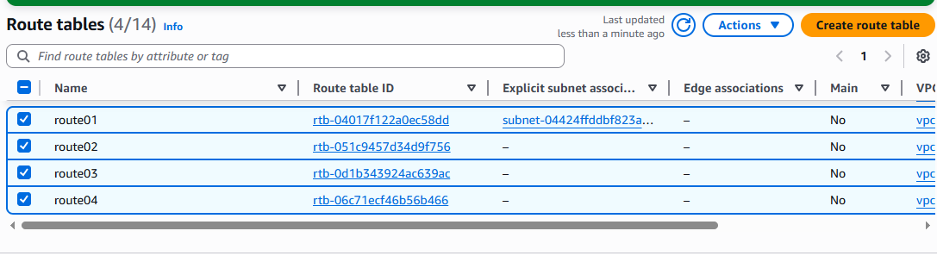
edit route tables and add multiple VPC CIDR to all route tables and add internet gateway.
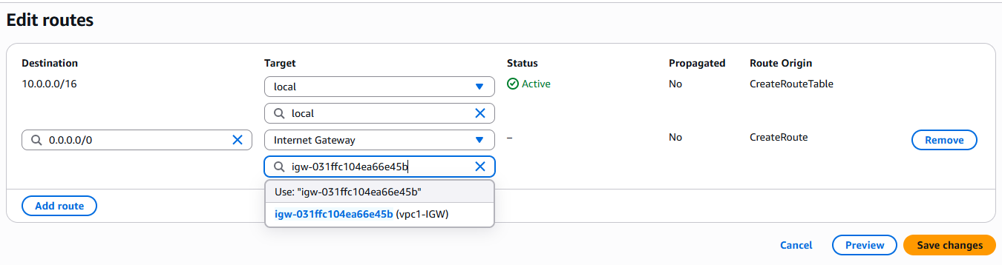

create transit gateway
attach transit gateway to multiple VPC
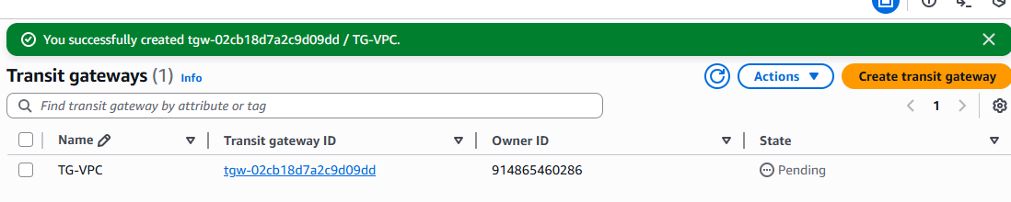
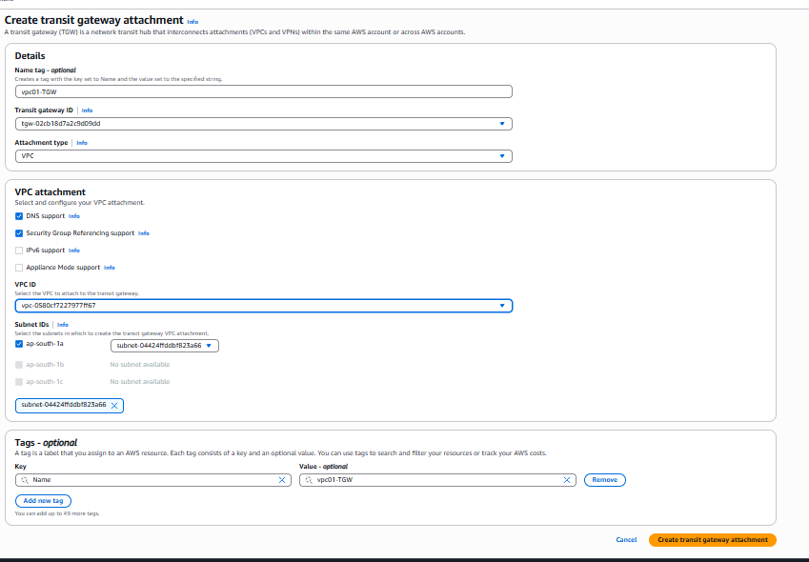
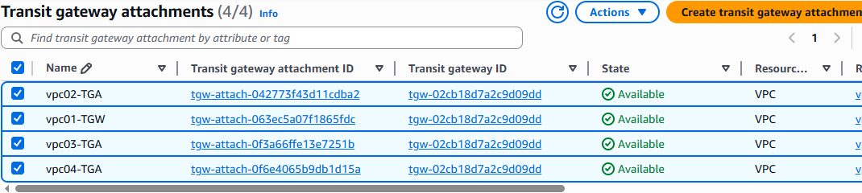
Edit all the route tables and add multiple VPC CIDR and add target to Transit Gateway and save the changes.
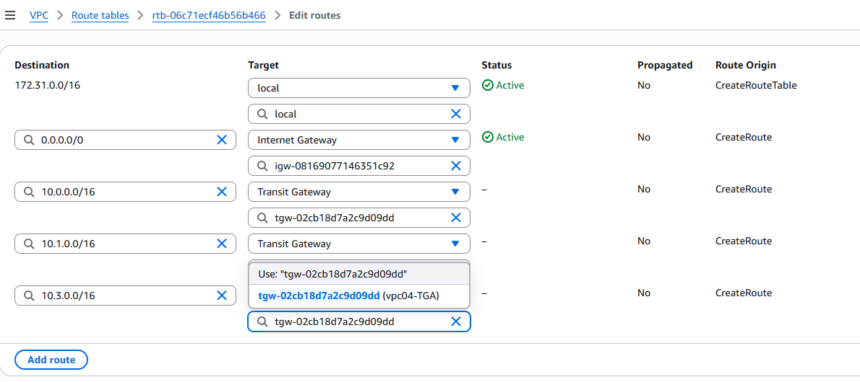

create multiple EC2 instance by adding multiple VPC to instance
change the instance inbound rules to allow all traffic 0.0.0.0/0

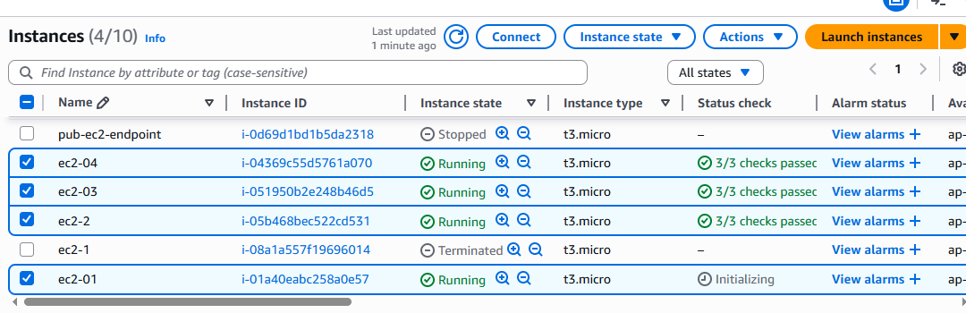
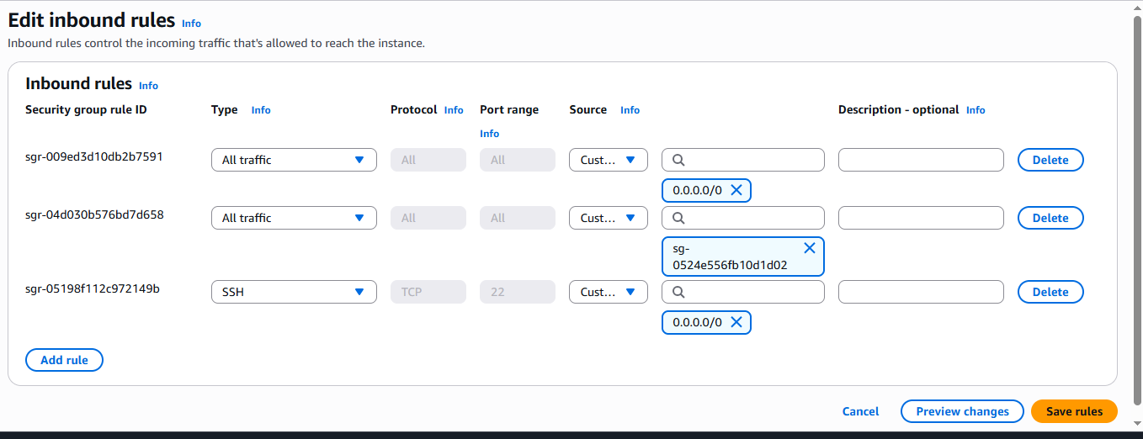
connect to one of the instance and ping with other instance private ip.
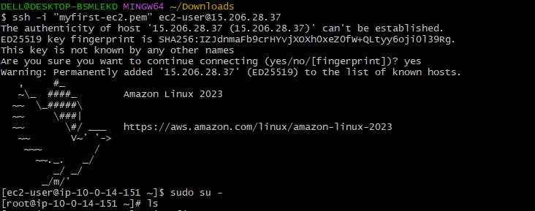
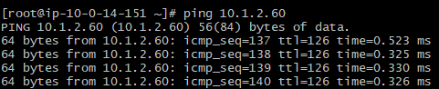
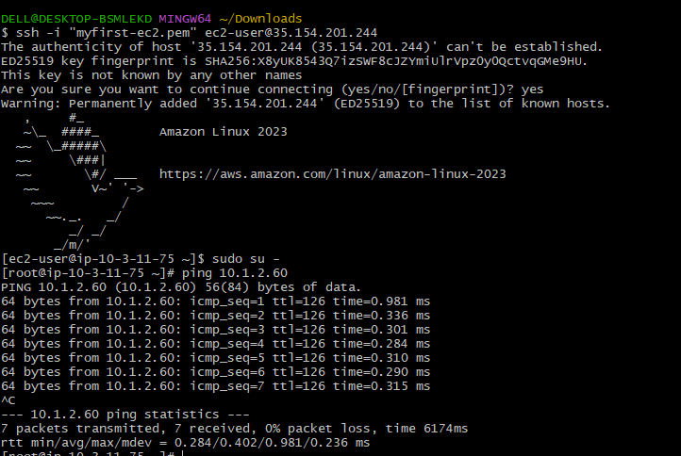

Set up a VPC Endpoint.

Go to aws console
Go to vpc-->create VPC
create internet gateway-->attach to created VPC
create 2 subnets public and private
create 2 route tables public and private
edit route table for public-->add route 0.0.0.0/0 target internet gateway
create 2 ec2 instances public and private one with public subnet and one with private subnet

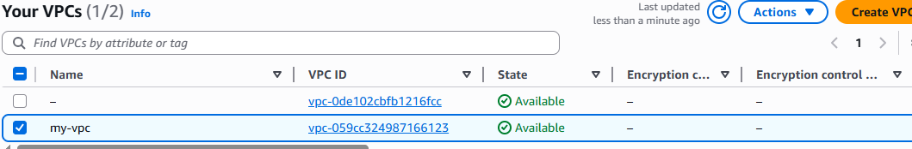
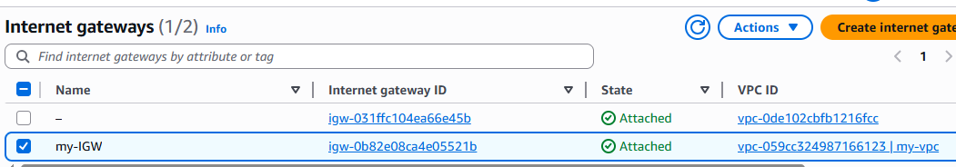
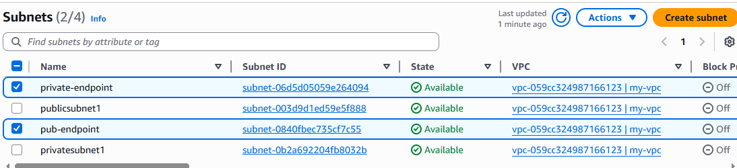
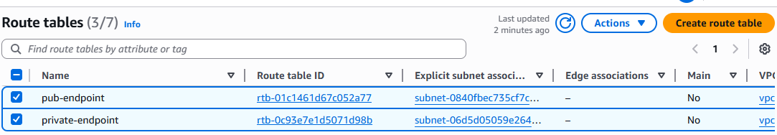
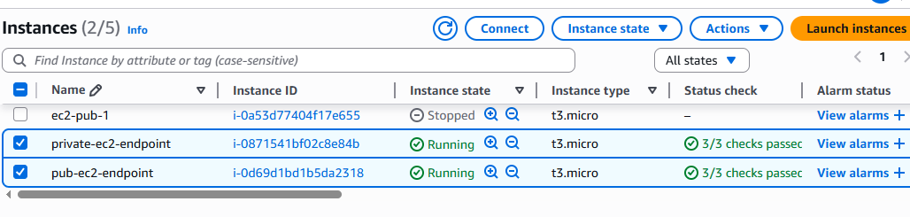
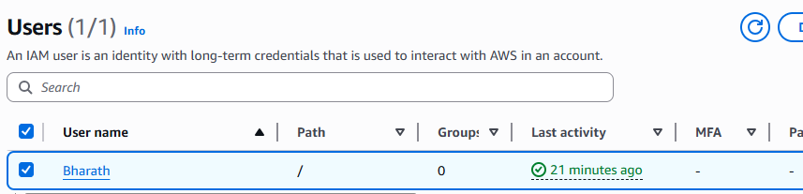

Go to endpoint service create endpoint by selecting gateway , adding s3-service-region, vpc and route table to private.
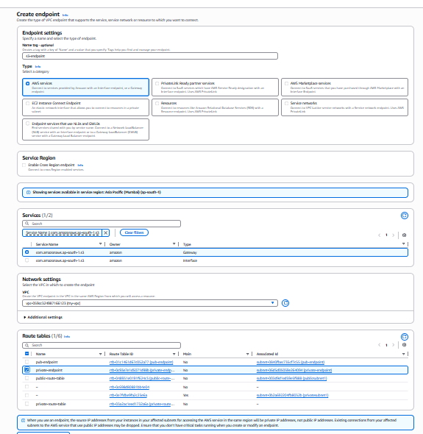
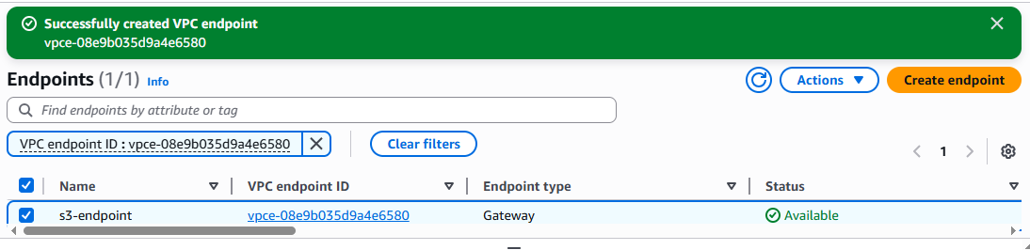
connect to public ec2 instance
Go to root sudo su -
aws configure
crate IAM user and generate key and password
give the access key and password, region and format
use command "aws s3 ls" to see the s3 logs
create a file and paste the pem key of public instance
Now login with private instance ip with in the same server
use command "aws s3 ls"-->command will not execute because we have created any endpoint.
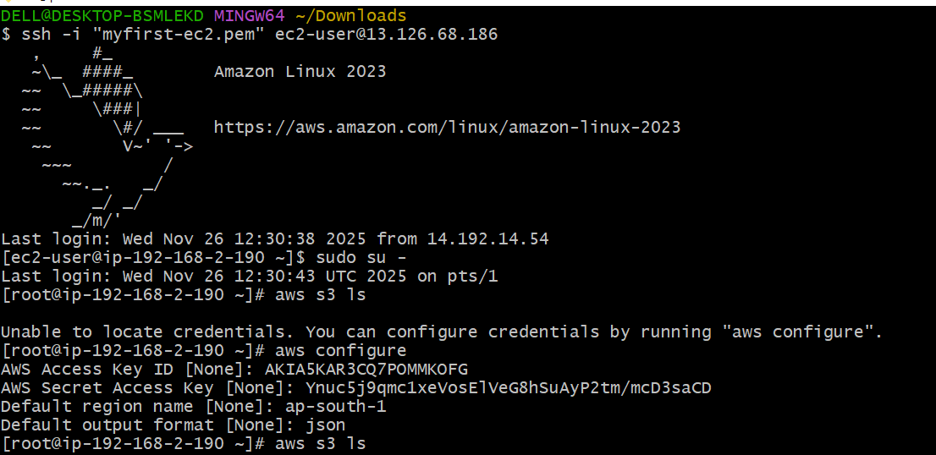
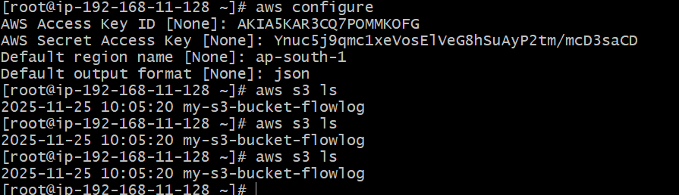
check in CLI with "aws s3 ls" the s3 logs will be available.

